**PHP Internship Report**

**Personal Details**

Name : Akash Padhiyar

College Name : Akash Technolabs

Degree : BE

Semester : 7

Github URL : <https://github.com/akashpadhiyar>

**Company Details**

Company Name : Akash Technolabs

External Guide : Akash Padhiyar

Training Duration : 26-05-2021 to 21-06-2021

**Index**

|  |  |  |
| --- | --- | --- |
| **Index** | **Task Detail** | **Page Name** |
| 1 | Hello World | 1 |
| 2 | Fetch Data From Database | 2 |
|  |  |  |
|  |  |  |
|  |  |  |

Note : You can Add Minimum 15 Screenshots and Maximum 50

Also Write Description in Each page

2- Fetch Data From Database Code

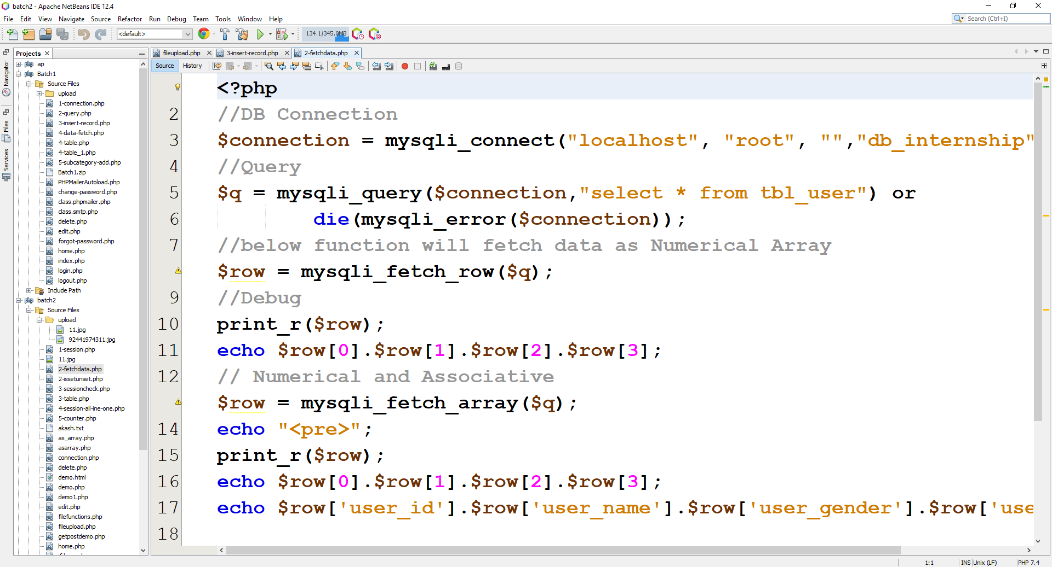

Output

